|  |
| --- |
| MSC ELECTRONICS ENGINEERING |
| DIGITAL CONTROL COURSEWORK1 |
| ITEC40081 |

|  |
| --- |
| BLOSMY KIZHAVANA JACOB  N1234298 |

Q1.

A)

A control loop mechanism that uses feedback is the PID controller. The three controllers that make up this system are the derivative, integral, and proportional controllers. The control system's impulse response characteristics and shape are determined by the coefficients of these controllers. In order to fulfill various control applications, these coefficients are necessary to balance parameters such as speed, stability, and overshoot and to obtain the desired system response.

When using a proportional controller, the "P" coefficient mostly influences the response's size and abrupt error change. Higher proportional gain results in the enrolling of proportional control action in the given error, which causes the control loop system to become unstable and begin to oscillate. Insufficient controller gain will result in insufficient response to the disturbances. EXAMPLE: INTERCHANGE REGULATOR

Think of a space that has a temperature control system. Keeping the temperature at 20 degrees Celsius is its primary goal. Temperature sensor, proportional controller, and heater make up this system. There will be a temperature differential from the set point for a while if the proportional gain is low since the controller will respond to errors slowly. The controller reacted fast to any temperature change if the proportional gain was high. This will force the heater to make frequent, rapid adjustments to the heating temperature, which will cause the control systems to oscillate and become unstable. With few oscillations and stable conditions, a well-turned P Value kept the room temperature near to the set point.

By constructing and fixing previous faults, "I" coefficients in an integral controller filter out steady state error. A larger "I" number will decrease the impulse response's steady state error, but if it is set too high, it may also cause instability and a slower response.

EXAMPLE: WATER LEVEL IN THE TANK Let’s say we have a tank of water that has to have a steady level. A pid controller is introduced to regulate the water level in the tank by adjusting the flow rate. Integral coefficients are used in the field to remove the water level's steady state inaccuracy. In order to remove any long-term deviation from the ideal water level, it gradually accumulates the error and modifies the flow rate. Should the water level drop below the intended level as a result of outside disturbances, the integral term will progressively rise, prompting the controller to raise the flow rate in order to reduce the steady state error.

By taking the rate of change into account, "d" coefficients in the derivative controller forecast future changes in errors. It aids in reducing the system's reactivity to stop oscillation and overshooting. EXAMPLE: SUSPENSION SYSTEM OF A CAR Think about an automobile suspension system that uses a pid controller to change the shock absorbers' damping force to provide a comfortable ride. The purpose of the "d" coefficient is to predict and absorb abrupt changes in the vehicle's location, particularly while it is rapidly accelerating or decelerating. The derivative term reacts to a quick change in position by acting against it by adding extra damping force. An example of this would be when the car hits a bump on the road. This aids in keeping the vehicle from bouncing.

B) Two popular techniques for transforming analog systems into digital systems are bilinear transformation and impulse invariant transformation, which are very useful when creating digital filters. The use of each approach varies according to the needs of the applications, and each has benefits and drawbacks of its own.

The process of **frequency warping** in bilinear transformation Compared to impulse invariant transformation, bilinear transformation preserves a superior frequency mapping.

The frequency mapping of the digital and analog systems is similar, which facilitates the analysis and construction of filters for a range of frequency responses.

**Stability**: When it comes to systems with high analog pole frequencies, bilinear transformation consistently yields digital filters that are more stable than impulse invariant transformation.

**More Accurate Approximation**: The technique reduces frequency distortion and makes it simple for the designer to adjust the phase in accordance with plans.

**Flexibility**: Flexibility exhibiting a range of properties, such as band-pass, high-pass, low-pass, and band-stop filters. For designing filters with intricate needs, it works well.

Analog systems' linear phase is maintained by it, which is essential in applications like audio processing and telecommunications where phase linearity is significant.

**Improved Control**: When employing bilinear transformation, designers have more influence over the properties of the digital filter. This enables the responsiveness of the filter to be adjusted to fit particular needs.

In the transformation of impulse invariant**, simplicity**: It is easier to use and less complicated. Continuous-time signals are directly converted into discrete-time sequences, directly transferring the analog system to the digital realm.

**Preserving the Poles**: It translates the poles of the analogue system to the poles of the discrete-time system directly for stability considerations.

**Systems in real time**: By using direct mapping instead of the more complicated bilinear transformation, you can lessen the computing load.

CHOICE IMPORTANCE:

Implementing the prerequisites: Depending on the different needs of the application, one can choose between the impulse invariant and bilinear transformations. When precise frequency representation and stability are crucial requirements, bilinear transformation is the chosen method. Impulse invariant transformation could be selected if simplicity and direct pole-zero mapping are the most important requirements.

Properties of the system: The decision of transformation methods was made based on the properties of analog systems, including frequency distribution and pole locations. For managing a broad variety of analog systems, bilinear transformation offers greater flexibility.

In conclusion, criteria such as stability, frequency accuracy, and system complexity determine whether to use bilinear or impulse invariant transformations, depending on the particular needs of the application.

Q2.

A) y[n] = x[n]-0.5x[n-1] +1.2y[n-1]-0.48y[n-2]

Apply the z transform to both sides of the difference equation.

Y(z) = X(z)-0.5z^ (-1) X(z)+1.2z^ (-1) Y(z)-0.48z^ (-2) Y(z)

Isolate Y(z) terms on one side.

Y(z) (1-1.2z^ (-1) +0.48z^ (-2)) = X(z)-0.5z^ (-1) X(z)

Dividing both sides by the common factor (1-1.2z^ (-1) +0.48z^ (-2))

So by simplify we get Y(z) =X(z) (1-0.5z^ (-1))/ (1-1.2z^ (-1) +0.48z^ (-2))

H(z)=Y(z)/X(z) = (1-0.5^ (-1))/ (1-1.2z^ (-1) +0.48z^ (-2)) ­­­­

B)

­­­­­­­­­­­­­­­­­­­­­­­­­­­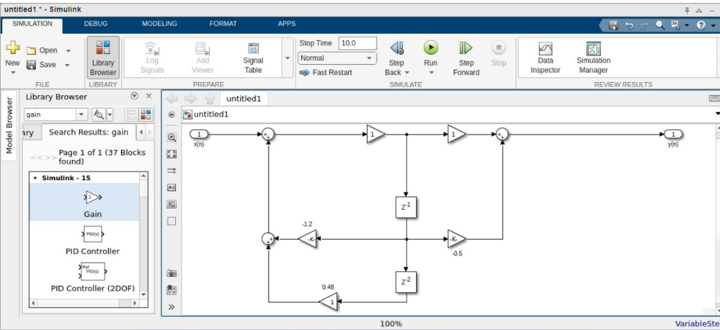

C)

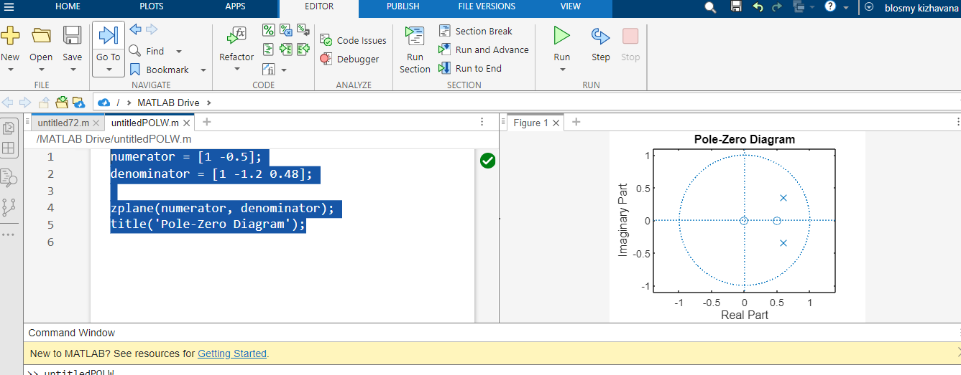

D)

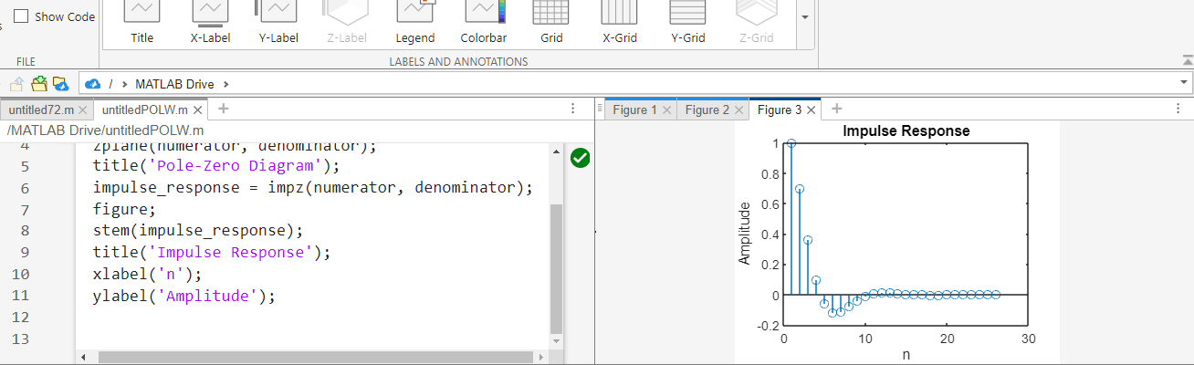

E)

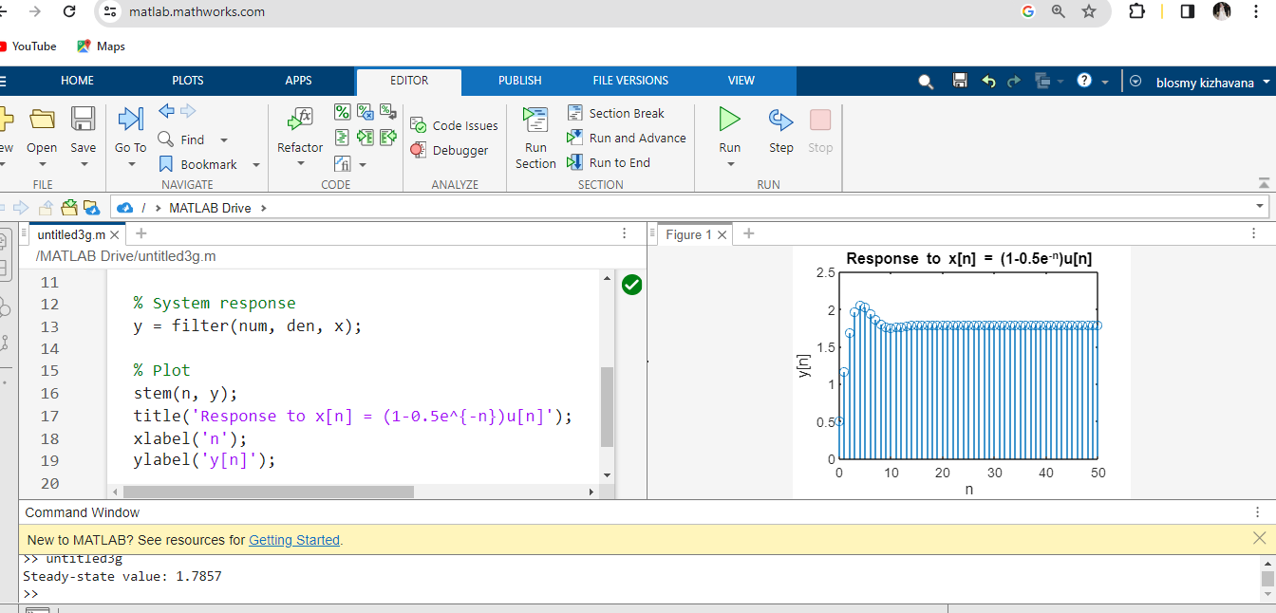

% Define transfer function

num = [1, -0.5];

den = [1 -1.2 0.48];

sys = tf (num, den, -1); % discrete-time system with unspecified sampling time

% Input signal

n = 0:50; % Example duration

x = (1 - 0.5*exp(-n)). *(n >= 0);

% System response

y = filter (num, den, x);

% Plot

stem (n, y);

title ('Response to x[n] = (1-0.5e^{-n}) u[n]');

xlabel('n');

ylabel('y[n]');

steady state = y(end);

disp (['Steady-state value: ', num2str (steady state)]);

Q3.

A)

% Design the digital filter

order = 4;

bandwidth = 0.35;

[b, a] = butter(order, bandwidth);

% Find parameters of the equivalent analog filter

fs = 10; % Sampling frequency

[analog_b, analog_a] = bilinear(b, a, fs);

% Find passband and stopband frequencies

passband_digital = bandwidth * fs / (2 * pi);

stopband_digital = (fs / 2) - passband_digital;

passband_analog = tan((pi * passband_digital) / fs);

stopband_analog = tan((pi * stopband_digital) / fs);

% Pole-zero diagram of the digital filter

zplane(b, a);

% Display passband and stopband frequencies

disp(['Passband Digital: ' num2str(passband_digital) ' Hz']);

disp(['Stopband Digital: ' num2str(stopband_digital) ' Hz']);

disp(['Passband Analog: ' num2str(passband_analog) ' rad/s']);

disp(['Stopband Analog: ' num2str(stopband_analog) ' rad/s']);

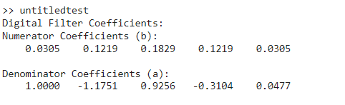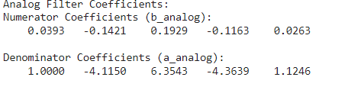

B)

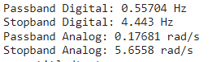

C)

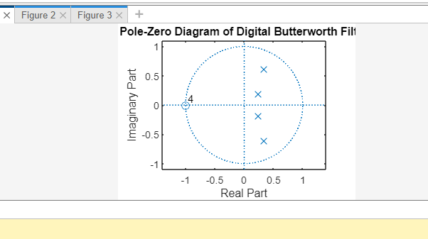

D) % Apply input signal

n = 0:99;

x = 2 * sin(8 * pi * n / fs) + 5 * cos(30 * pi * n / fs);

% Filter the input signal

y = filter(b, a, x);

% Plot frequency response

freqz(b, a, 512, fs);

% Display input and output signals

figure;

subplot(2,1,1);

plot(n, x);

title('Input Signal');

subplot(2,1,2);

plot(n, y);

title('Output Signal');

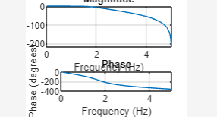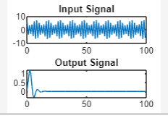

Q4.

A) The conditions for stability in both the analogue and digital domains are as follows:

In analogue systems represented by transfer functions, the system is stable if all the poles of the transfer function have negative real parts. That means the real parts of all the poles must be less than zero.

In digital systems represented by transfer functions, the system is stable if all the poles of the transfer function lie inside the unit circle in the complex plane. In other words, the magnitude of each pole must be less than one.

B)

i)H1(s) = s/(s+0.2): it is a first order system with single pole. The transfer function has a single pole at s = -0.2,

s+0.2 =0 since the real part of the pole is negative (-0.2<0), the system is stable.

ii)H2(s) = 1/(s^2+1):it is a second order system with complex conjugate poles, equation is obtained by denominator equal to zero, s^2+1 = 0 .it has complex conjugate roots. Solving this equation, we get imaginary units. Since the poles are purely imaginary, the system is marginally stable.

iii)H3(s)= s-1/s^2-0.4s-0.05: To obtain the equation, the denominator equal to zero

s^2-0.4s-0.05 = 0, use quadratic equation to find the roots

by solving we get, s =1, s= -0.5, both roots have a non-negative real parts, that’s indicate the potential instability in the system.so, this is system is not stable.

C)i.H1(z) is stable, because pole lie inside the circle.

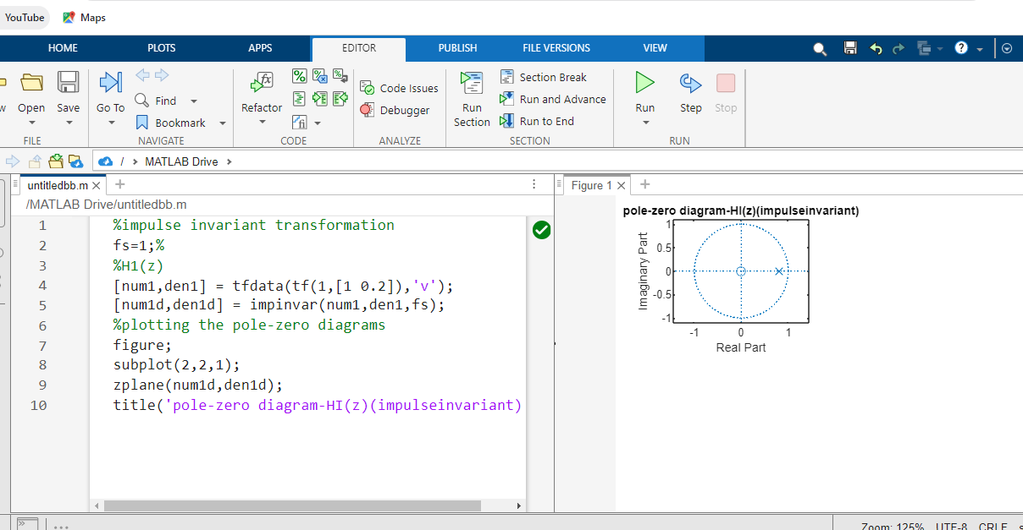

H2(z) is stable, because there is pole is inside the unit circle.

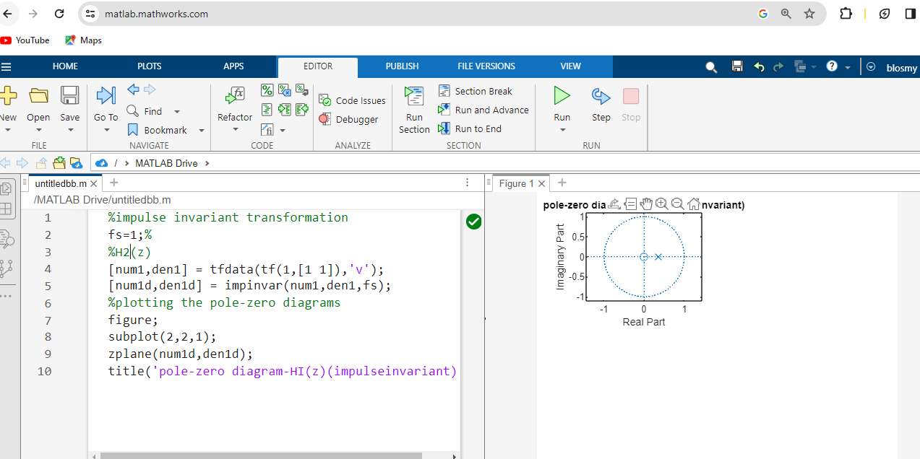

H3(z) is unstable, because the pole is outside the unit circle.

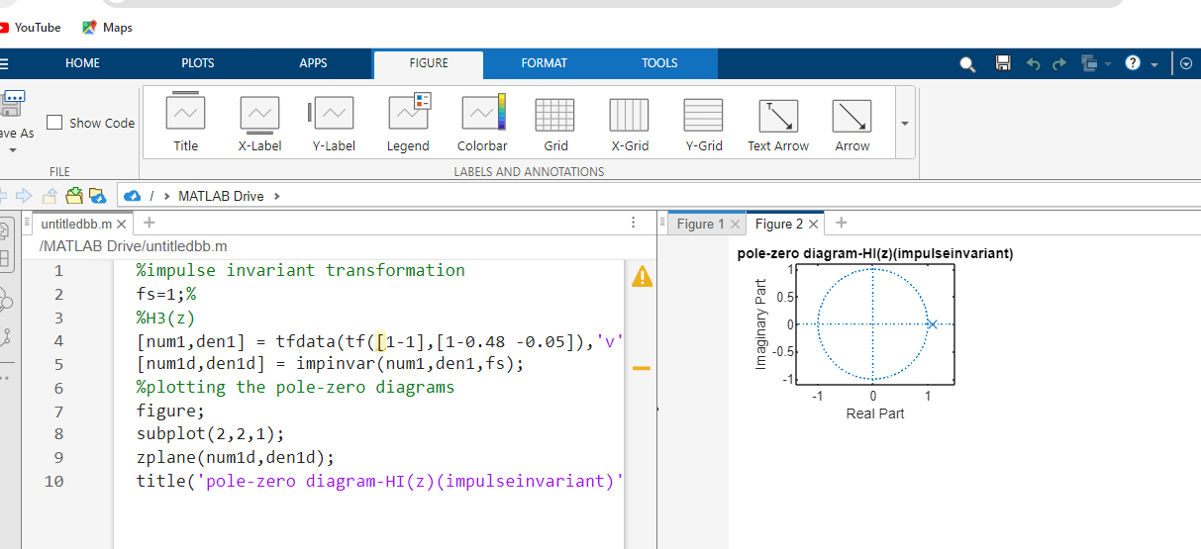

ii)For H1(z) system is stable.

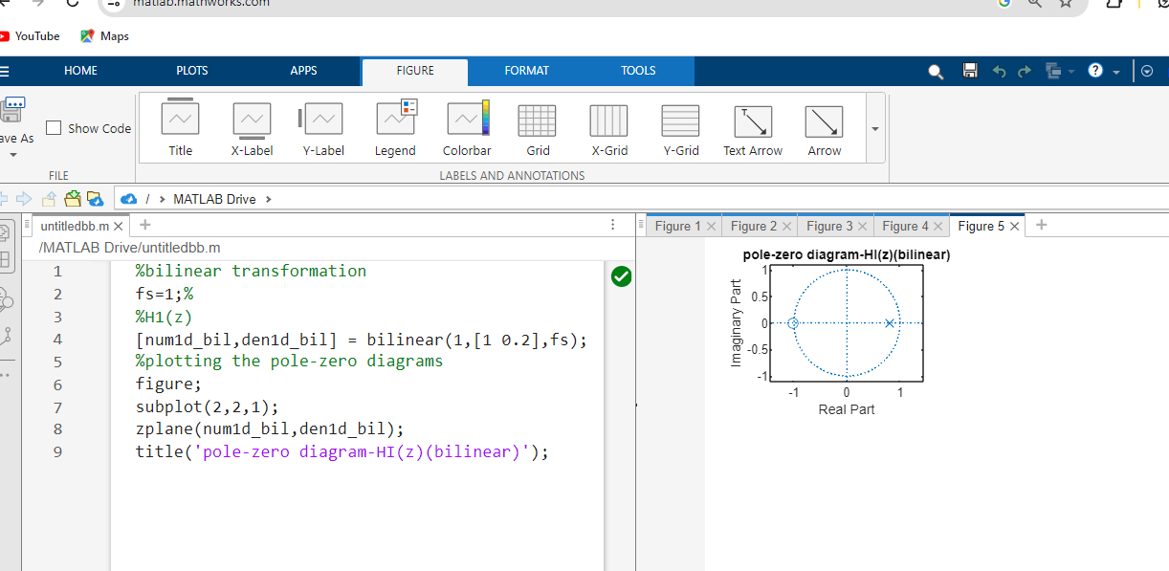

H2(z) is stable

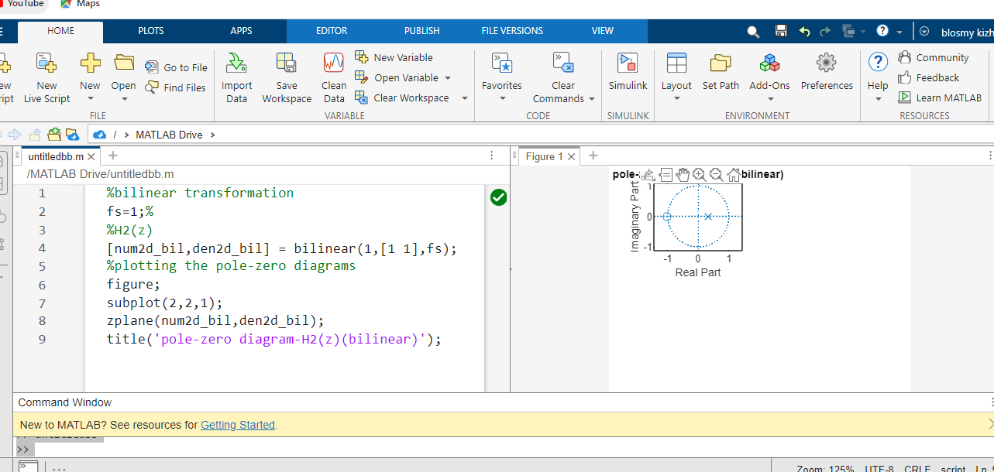

H3(z) is marginal stable

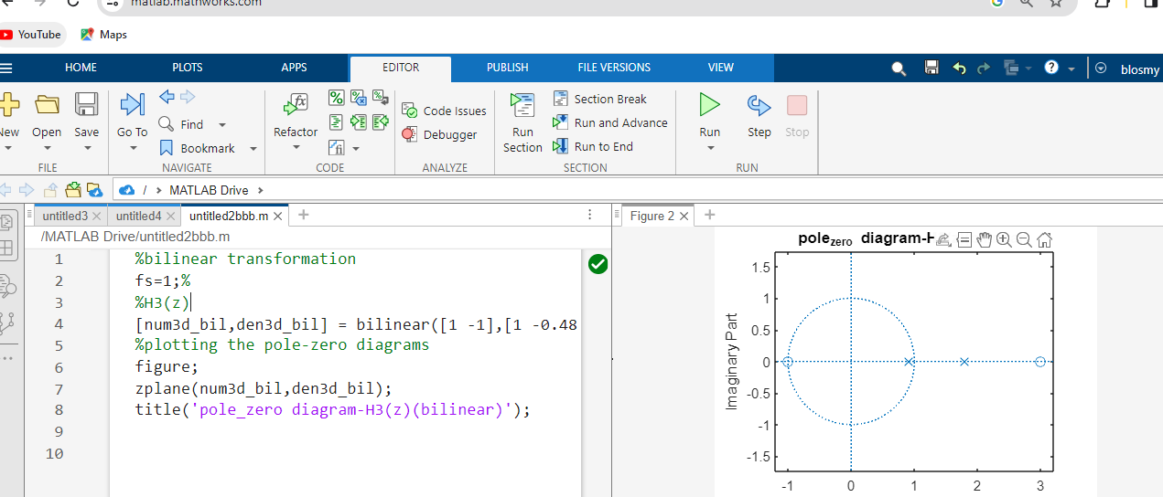

D)

impulse response and unit response

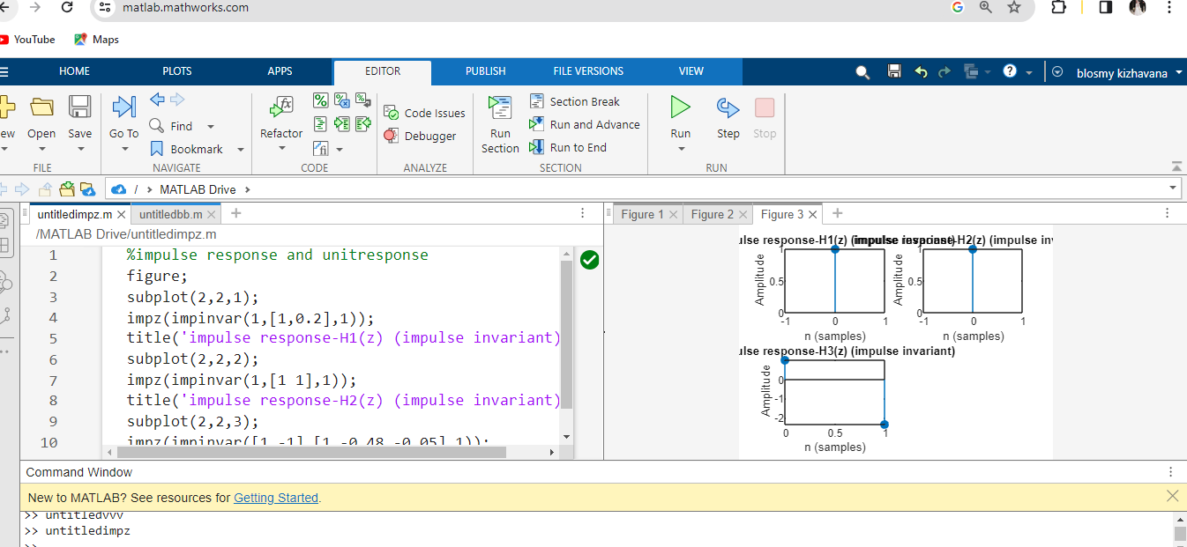

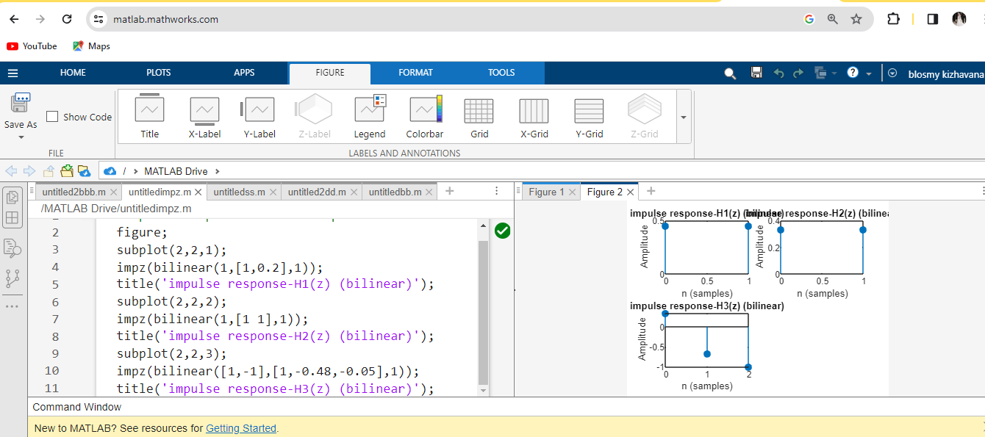

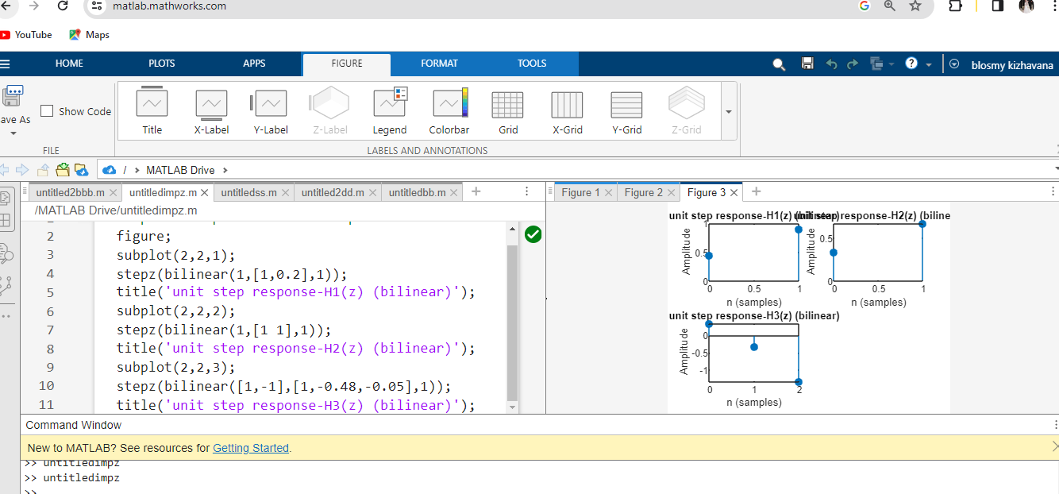

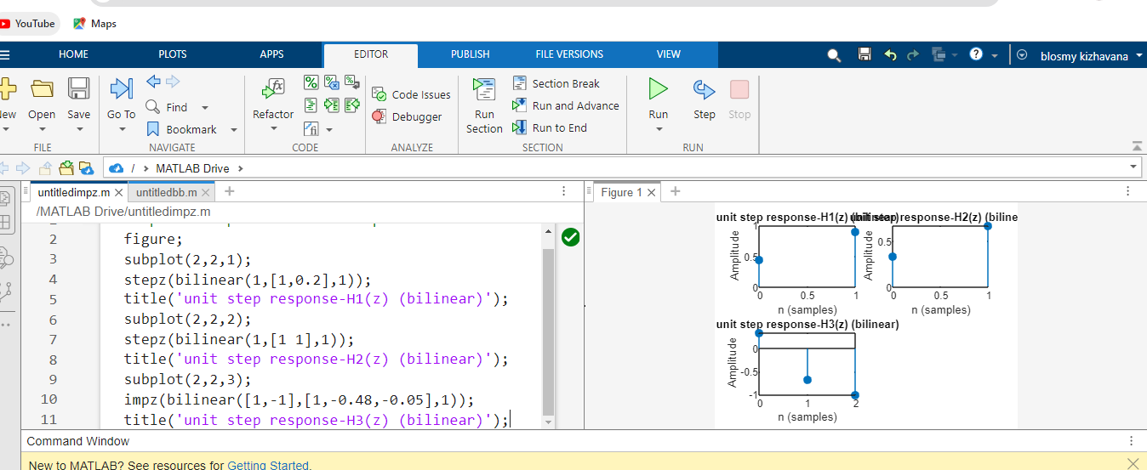

Q5.

A)

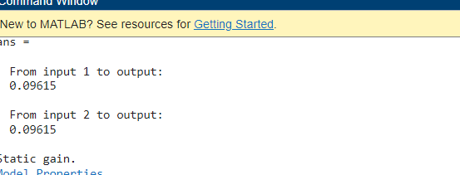

%Define the numerator and denominator of the analogue plant transfer

%function H(s)

num=2;

den = [1 ,0.8];

Hs = tf (num, den);

%define sampling frequency

fs=10; % Hz

%convert H(s) to digital system using bilinear transformation

Hz=bilinear (num, den, fs);

tf(Hz)

%display the digital system transfer function

disp ('digital system transfer function:');

disp(Hz);

%Define the numerator and denominator of the analogue plant transfer

%function H(s)

num=2;

den = [1 ,0.8];

Hs = tf (num, den);

%define sampling frequency

fs=10; % Hz

[num_d, den_d] =bilinear (num, den, fs);

%convert H(s) to digital system using bilinear transformation

Hz=tf (num_d, den_d, fs);

% plot the pole-zero diagram

figure;

pzmap(Hz);

title ('pole-zero diagram');

%plot for impulse response

figure;

impulse(Hz);

title ('impulse response');

%plot the frequency response

figure;

bode(Hz);

title ('Frequency Response ');

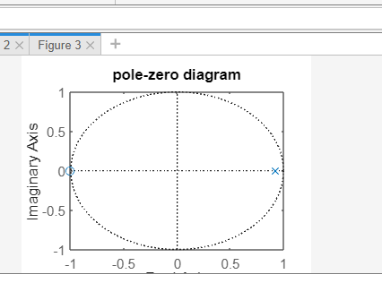 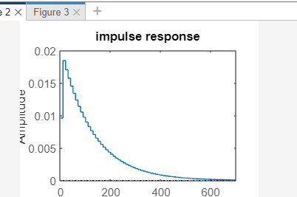 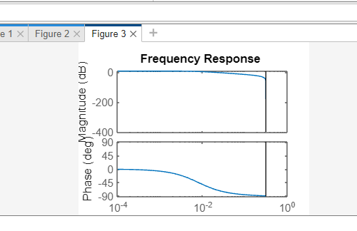

B) Feedback of transfer function,

Y(s)/X(s)=G(s).H(s)/1+G(S).H(s)

G(s) = k, H(s)= 2/s+0.8

Put into equation

We get

**H(s)=2k/s+0.8+2k**

To find pole of transfer function take roots of denominator

S0 s= -0.8 -2k

So k>-0.4, The real part of pole is negative, so the system became stable

C)

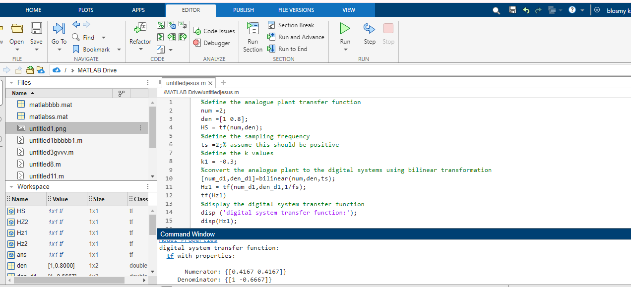

**D)**

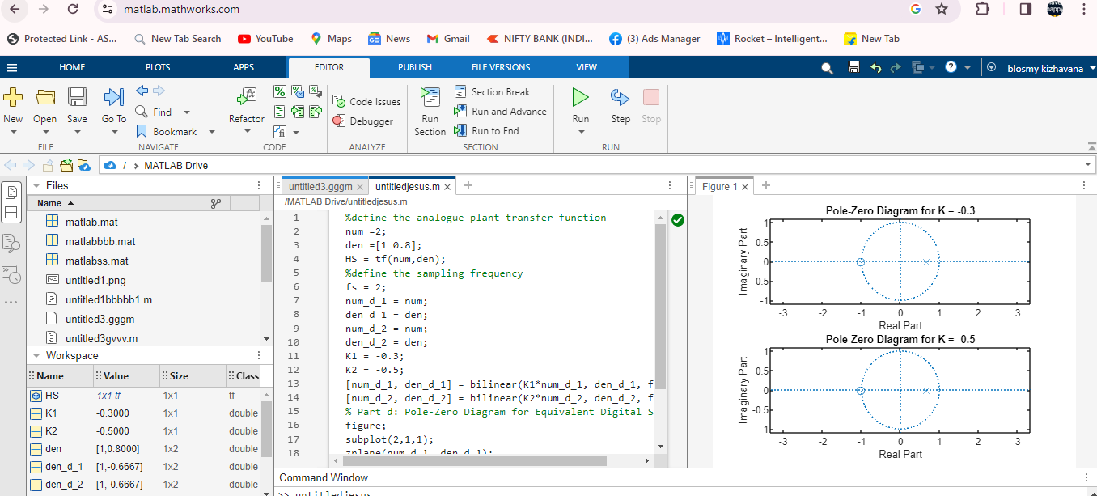

**E)**

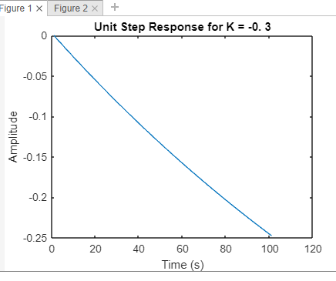 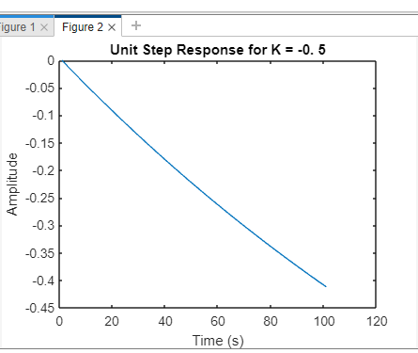

%define the analogue plant transfer function

num =2;

den = [1 0.8];

HS = tf (num, den);

%define the sampling frequency

fs =2;

num_d_1 = num;

den_d_1 = den;

num_d_2 = num;

den_d_2 = den;

K1 = -0.3;

K2 = -0.5;

[num_d_1, den_d_1] = step (K1*num_d_1, den_d_1, 1/fs);

[num_d_2, den_d_2] = step (K2*num_d_2, den_d_2, 1/fs);

% Plot the unit step responses

figure;

plot ([num_d_1, den_d_1]);

title ('Unit Step Response for K = -0. 3');

xlabel ('Time (s)');

ylabel('Amplitude');

figure;

plot ([num_d_2, den_d_2]);

title ('Unit Step Response for K = -0. 5');

xlabel ('Time (s)');

ylabel('Amplitude');